# coding=utf-8
from socket import *
from threading import Thread
def recv_data():
while True:
recv_data = client_socket.recv(1024)
recv_content = recv_data.decode('gbk')
print(f"客户端说：{recv_content},来自{client_info}")
if recv_content == "end":
print("结束接收消息")
break
def send_data():
while True:
msg = input(">")
client_socket.send(msg.encode('gbk'))
if msg == "end":
print("结束发送消息！")
break
if __name__ == '__main__':
server_socket = socket(AF_INET, SOCK_STREAM)
server_socket.bind(("127.0.0.1", 8899))
server_socket.listen(5)
print("等待接收连接！")
client_socket,client_info = server_socket.accept()
print("一个客户端建立连接成功！")
t1 = Thread(target=recv_data)
t2 = Thread(target=send_data)
t1.start()
t2.start()
t1.join()
t2.join()
client_socket.close()
server_socket.close()
以上是服务端的代码，RUN后正常出现下图
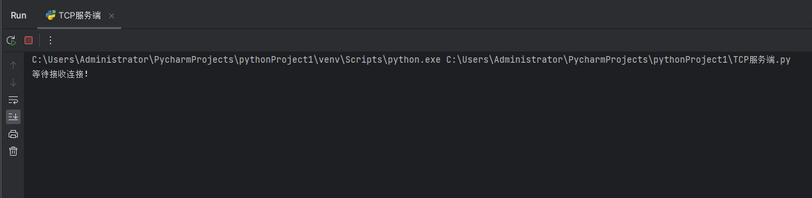

以下是客户端代码，run服务端后运行客户端开始出现问题

# coding=utf-8
from socket import *
from threading import Thread
def recv_data():
while True:
# 接收服务器端数据
recv_data = client_socket.recv(1024)
recv_content = recv_data.decode('gbk')
print(f"服务端说：{recv_content}")
if recv_content == "end":
print("结束接收消息")
break
def send_data():
while True:
# 给服务端发消息
msg = input(">")
client_socket.send(msg.encode('gbk'))
if msg == "end":
break
if __name__ == '__main__':
client_socket = socket(AF_INET, SOCK_STREAM)
client_socket.connect(("127.0.0.1", 8899))
t1 = Thread(target=recv_data)
t2 = Thread(target=send_data)
t1.start()
t2.start()
client_socket.close()

运行客户端出现下面截图的问题，我检查了几次（含度娘）代码无法解决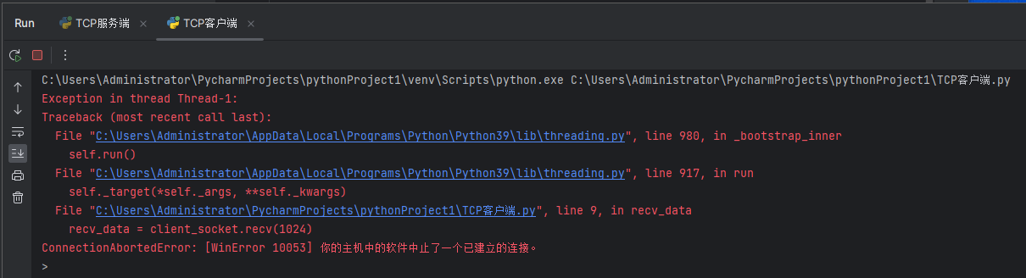回到服务端，服务端也出现如下问题，思来想去菜鸟无法解决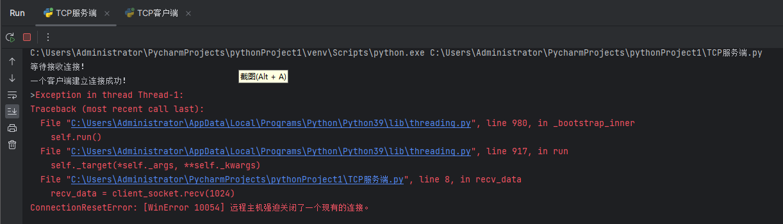望老师答疑